5/29/2024
Got together with the group. We started talking about the basics of kite design but did nothing. Got meeting times down.

5/30/2024
Made a plan for the coming weeks. Planned the first prototype. The idea is to glue together some dowels and trash bag film to make a delta kite, then test it.

6/05/2024
- We connected the servo to gemma mo and used arduino IDE to create basic servo movement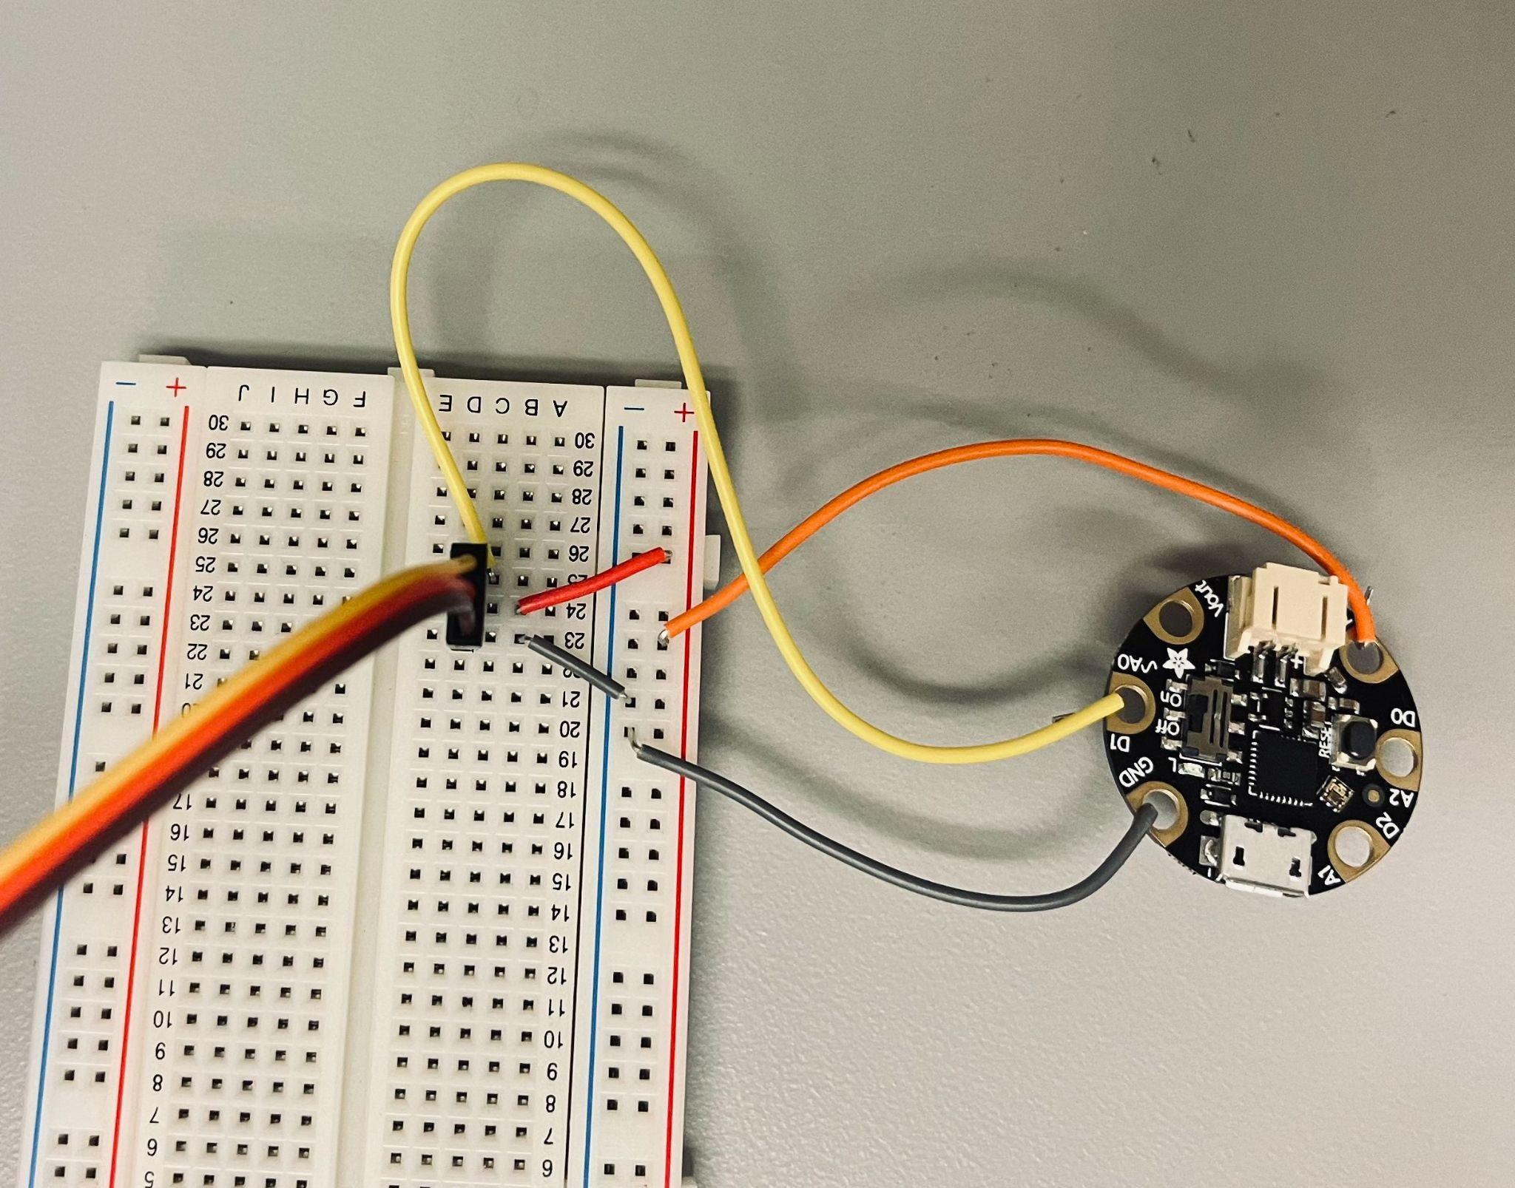

- To set up arduino IDE for gemma mo:
- Go to IDE settings and type in https://adafruit.github.io/arduino-board-index/package_adafruit_index.json in the Additional boards manager URLs. Click OK.
- Go to Tools>Board>Board Managers> and install Adafruit SAMD Boards
- Then go back to Tools> Board>Adafruit SAMD boards> choose Adafruit Gemma Mo
- Then go to Programmer> choose Atmel-ICE
- Then go to Port and choose the appropriate port where the Gemma is connected
- Start coding> press upload

- Parts to design:
- We need to start designing a connecter that holds connects the servo to the wings’ spar so that we can move the wings up and down
- We also need to design a holder for the servo that will sit on the middle spar

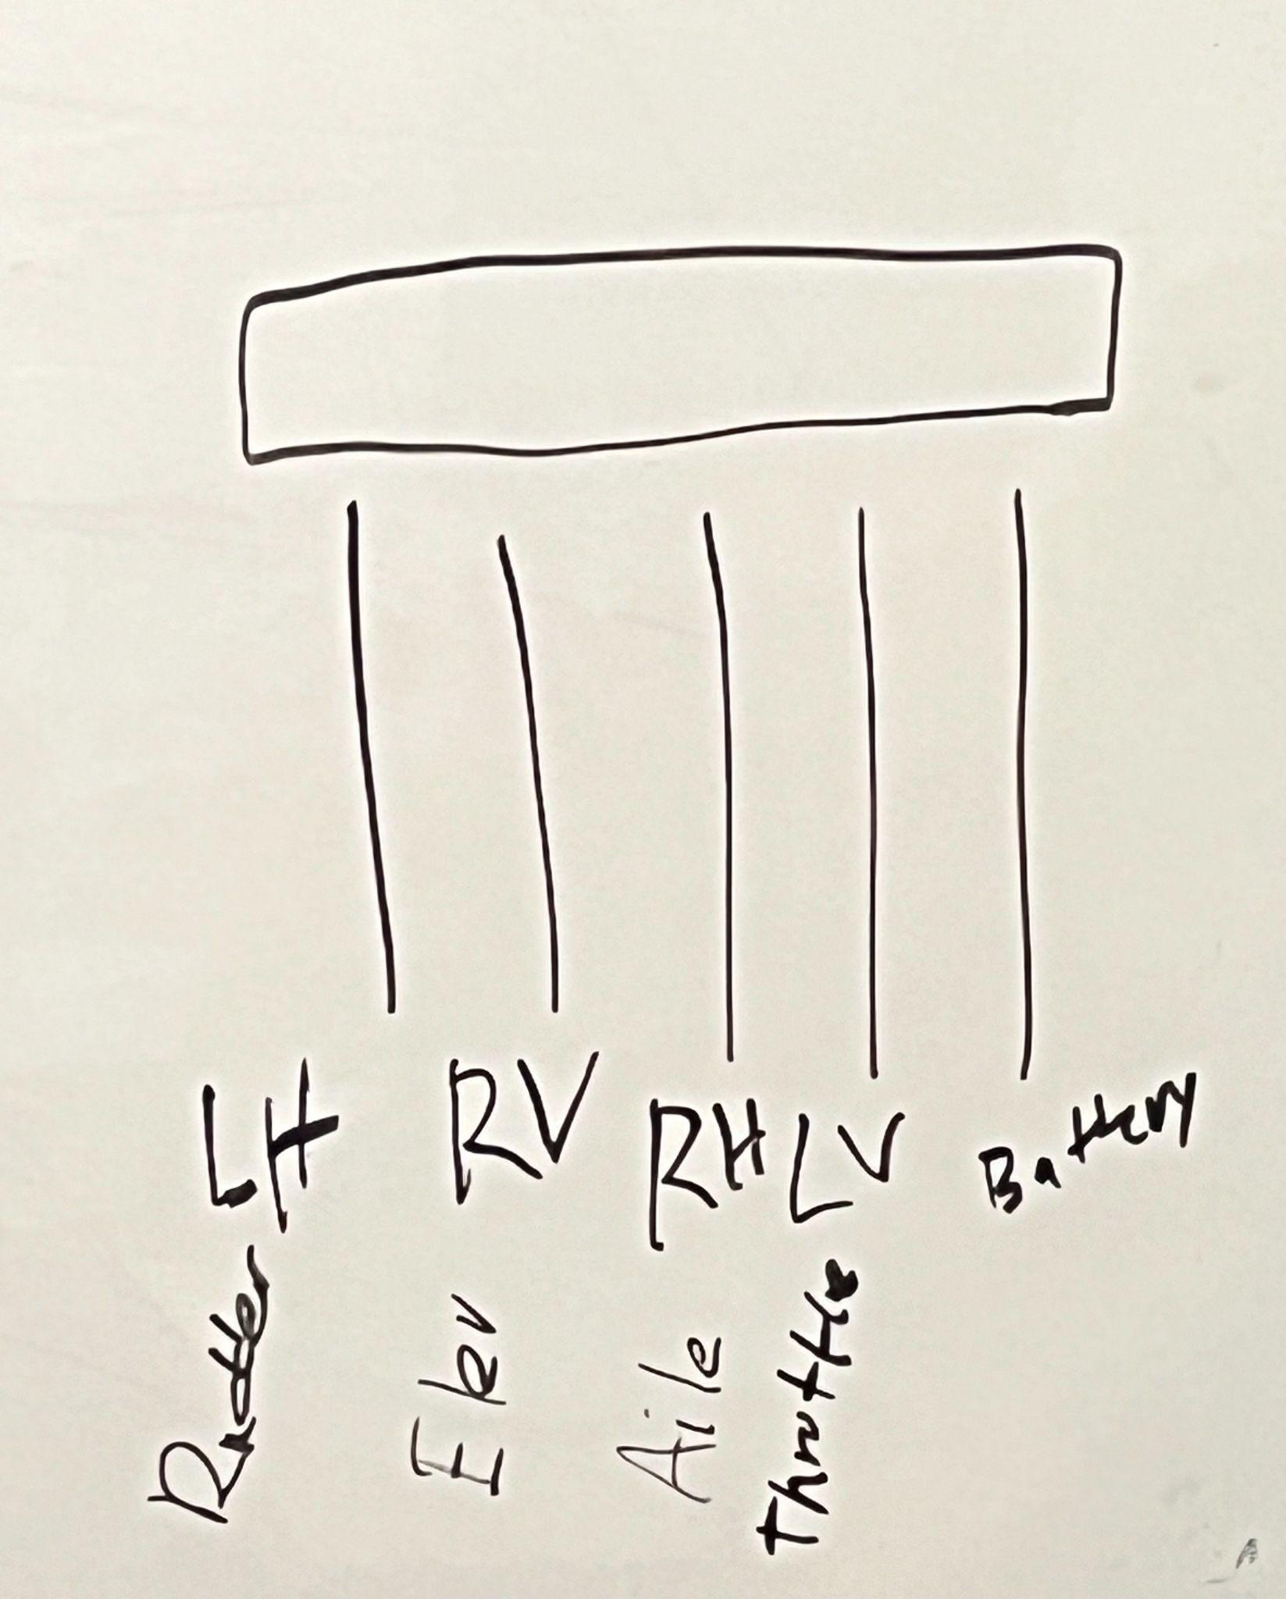
06/06/2024

06/07/2024

Channel Values for Spektrum Controller
 | -a (min) | 0 | +a (max)
Thot (2) | 1098 | 1468 | 1880
Aile (3) | 1777 | 1470 | 1191`
Elev (4) | 1317 | 1605 | 1895
Budder (5) | 1780 | 1490 | 1200

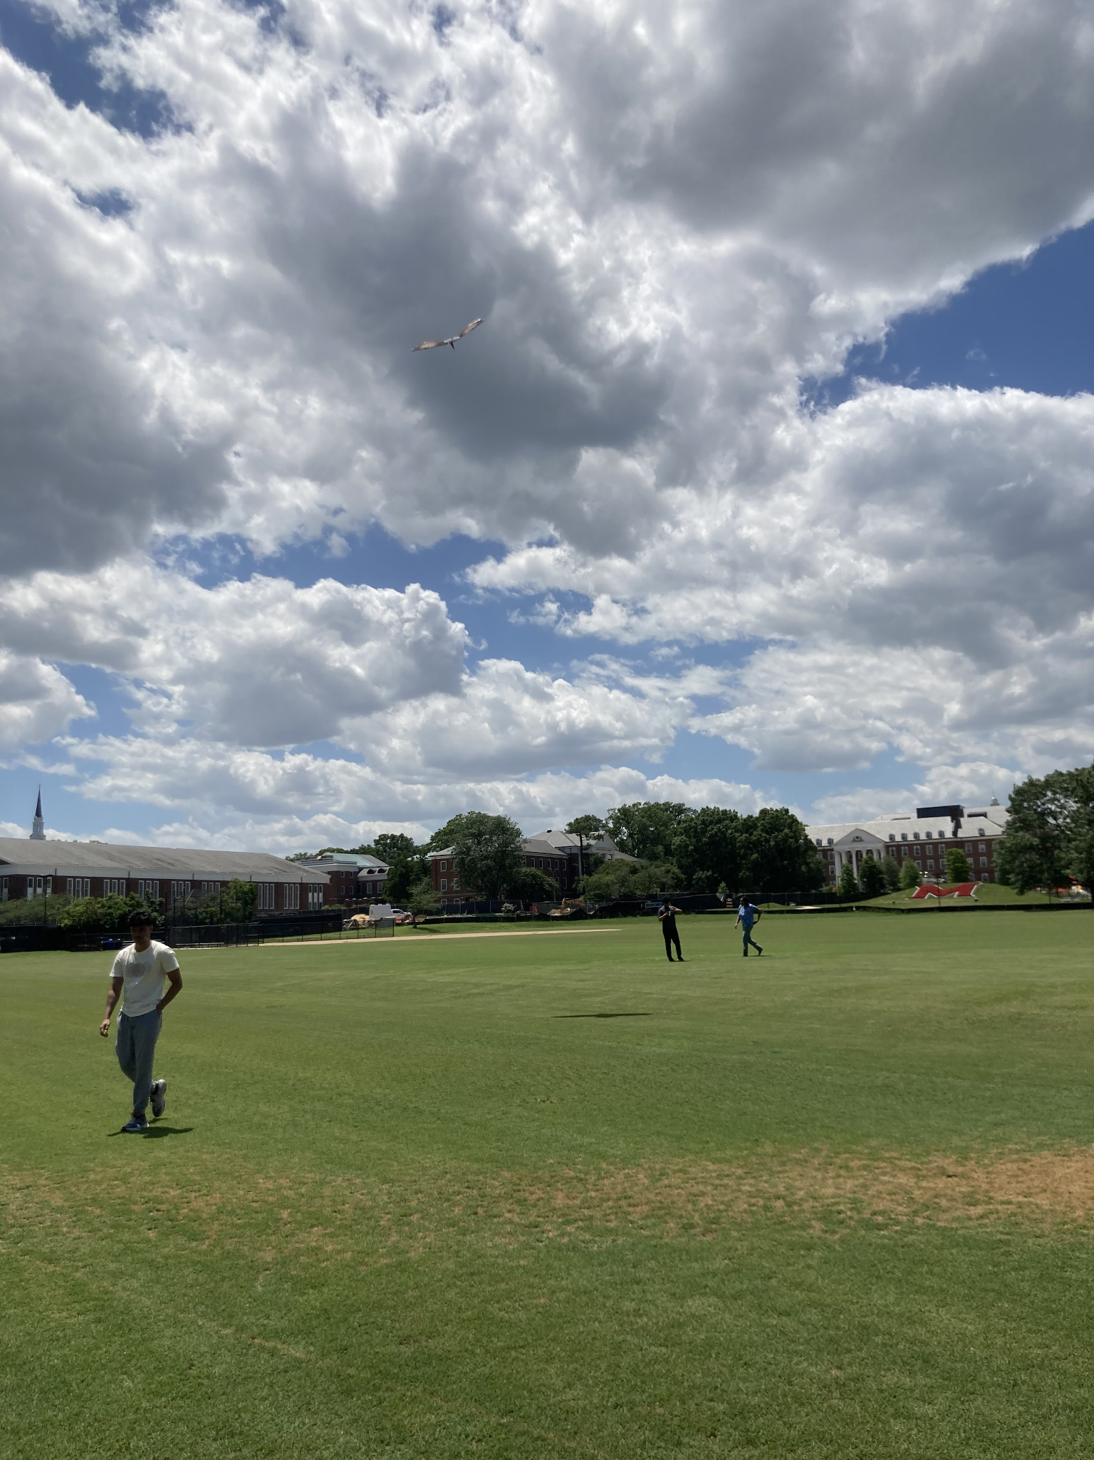

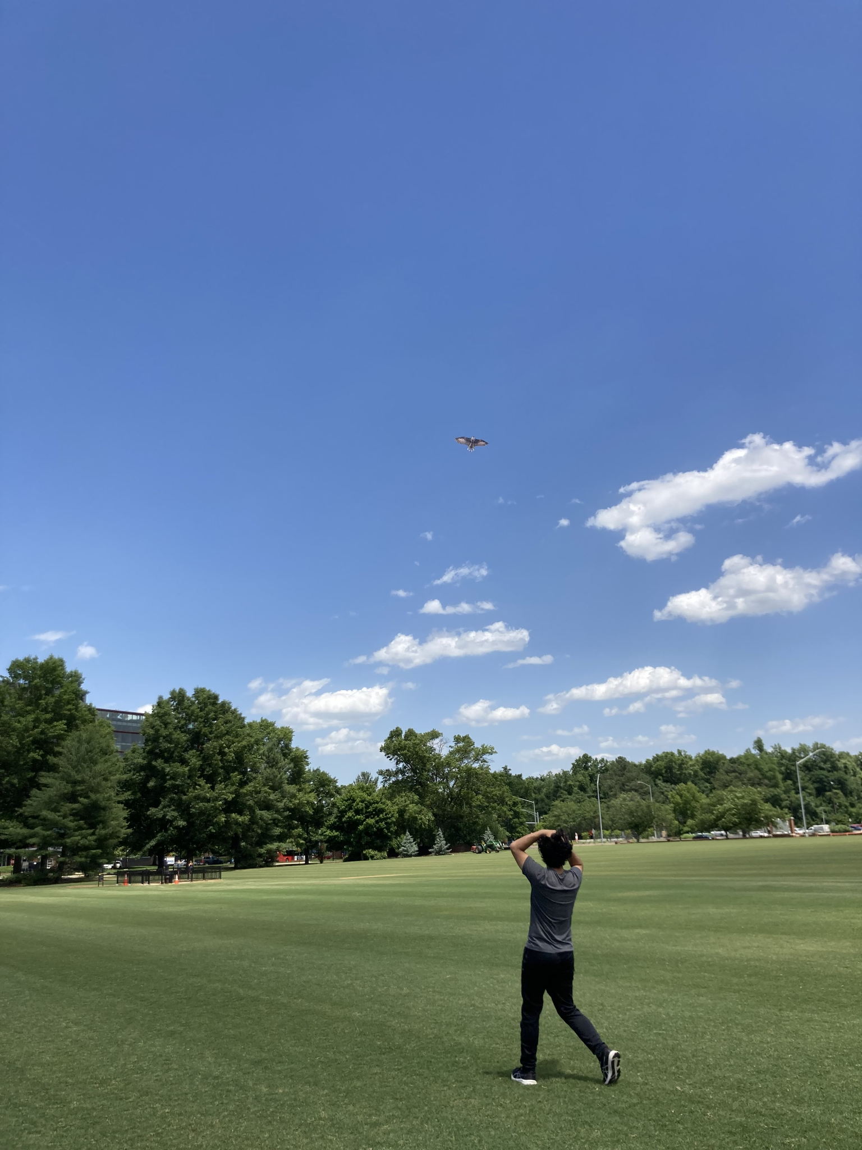
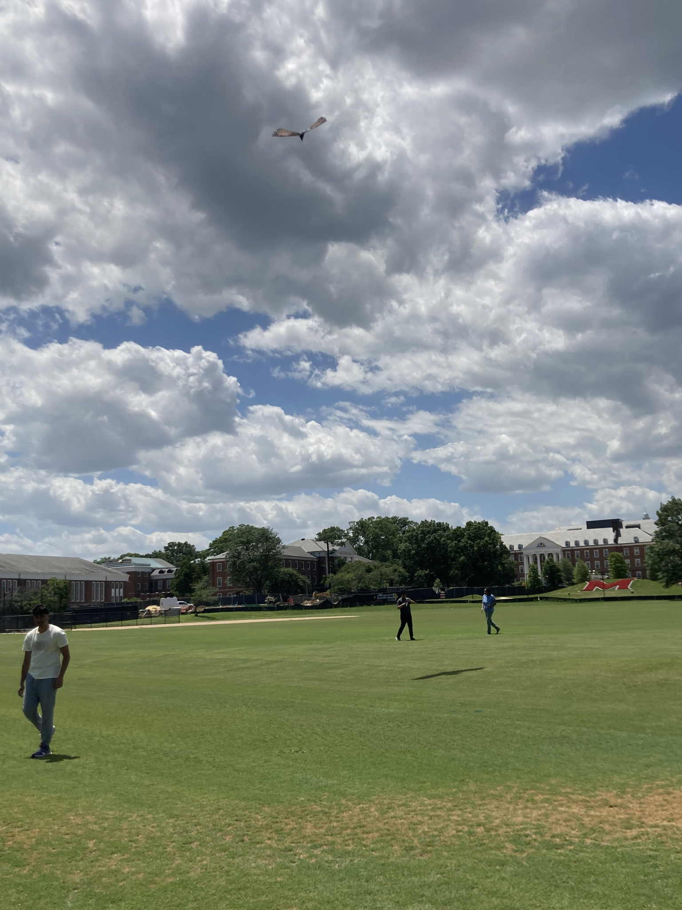
6/10/24

Sai Retest

Min/Max
 | -a (min) | 0 | +a (max)
Battery (2) | — | — | —
Thot (3) | 1084 | 1468 | 1893
Aile (4) | 1844 | 1470 | 1039
Elev (5) | 1207 | 1605 | 2000
Budder (6) | 1950 | 1490 | 1144

Actual Control (we want to create a range where nothing happens)
Flap frequency | -a (min) | 0 | +a (max)
Battery (2)
Thot (3) | 1184 |  | 1793
Aile (4) | 1744 |  | 1139
Elev (5) | 1307 |  | 1900
Budder (6) | 1850 |  | 1244

6/27

Got the high torque servo working. It accepts a range of 700 to 2294 instead of the theoretical 700-2300 but yeet. Even more theoretical the adafruit docs say it should be 1000-2000 but at this point field robotics does as field robotics does.

